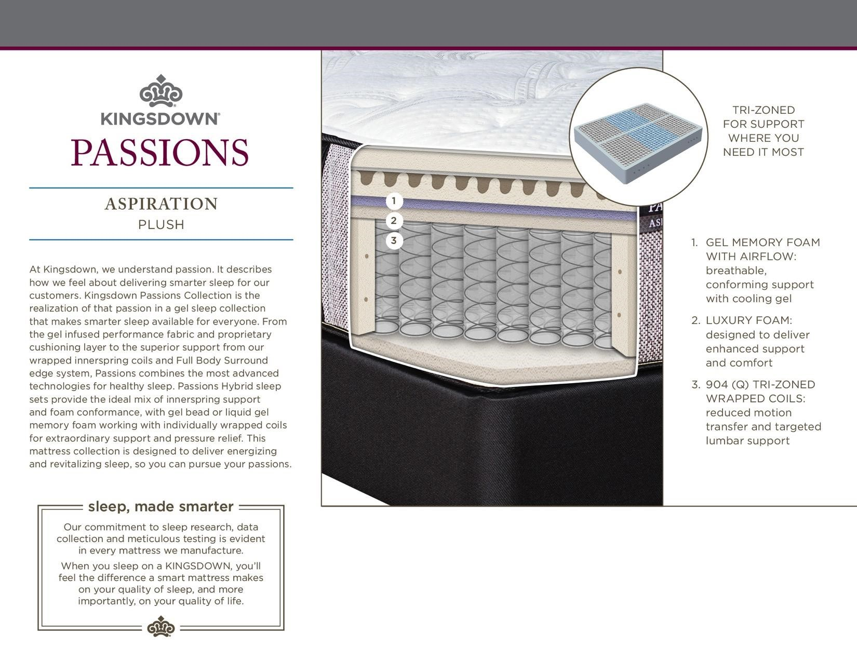

TWIN

FULL

QUEEN

KING

**$0,000**

**$0,000**

**$0,000**

**$0,000**

SET

SET

SET

SET

**$0,000**

**$0,000**

**$0,000**

**$0,000**

MOTION BASE

MOTION BASE

MOTION BASE

MOTION BASE